new mexico arts, department of cultural affairs
407 galisteo street, suite 270, santa fe nm 87501
505.827.6454 (phone) 1.800.879.4278 (instate) 505.827.6043 (fax)
www.newmexicomusic.org

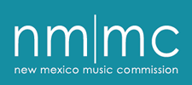

State of New Mexico Music Commission
Education Committee
Meeting Minutes
date & time

I.

II.

III.

IV.

V.

Next meeting {date & time} via Zoom.

